National University of Computer and Emerging Sciences



Lab Manual 10

Data Structures Lab

| Course Instructor | Dr. Saira Karim |
| --- | --- |
| Lab Instructor (s) | Fariha Maqbool  Muntaha Zaigham |
| Section | 3E |
| Semester | Fall 2022 |

Department of Computer Science

FAST-NU, Lahore, Pakistan

## Objectives

After performing this lab, students shall be able to:

* Learn and practice AVL trees

Implement a template based AVL tree and create the functions described below:

* Create a function ‘**insert’** to insert a node into AVL keeping in view that the tree remains balanced after insertion.

For this task you need to compute the **Balancing Factor (BF)** of each node

Implement functions for four types of rotation namely **RR, LL, LR** and **RL**

Create a function to compute the BF of each node.

**Node *RotateRight(Node *y)**

**Node *RotateLeft(Node *x)**

**Int balanceFactor(Node *n)**

**Node *insert(Node *node, int val)**

* Create a function **‘isAVL’** which takes a tree as argument and tells whether the tree is an AVL or not.
* A **‘search’** function to search an element in the tree **Bool search(int val)**
* A **recursive** function ‘**findmin’** that finds the minimum element using recursion.
* **A recursive** functions **‘find2ndmin’** that finds the 2nd minimum element in tree
* A **‘print’** function to print the **inorder, preorder** and **postorder** traversal
* A ‘**delete**’ function to delete an element from AVL tree. **node *Delete(node *,int);**

A suitable main function to test the above functions.

**Note: You can make any helping functions to complete the above functions.**

**Task:**

**Your task is to create an AVL tree for months of a year. The function should accept an array of months of a year and convert that array to AVL tree. Months are inserted into the AVL trees alphabetically.**

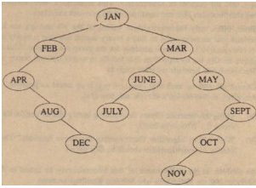

**tree created after insertion in BST**

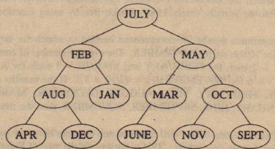

**tree created after insertion in AVL**